

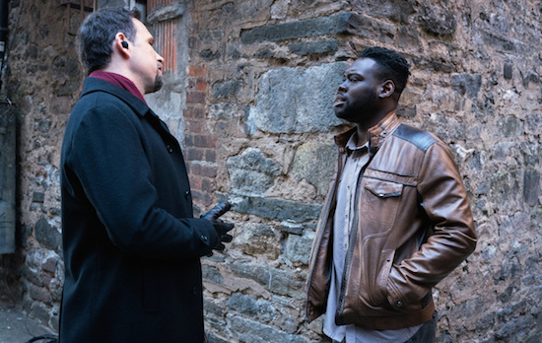

**Meet and Greet**

**Meet and Greet Session:**

Overview:

Applicants who successfully pass the Phase I test and complete the Required Information portion of the application will be invited to a Meet and Greet session, which is held at their PFO. During the Meet and Greet session, applicants will be able to speak directly to an FBI Special Agent, learn about Bureau policy requirements, verify and expand on the information they provided in their resume and ask questions about the position and/or process. Applicants are expected to wear professional business attire to the Meet and Greet session.

After an applicant has completed the Meet and Greet session and submitted any additional required documentation, his or her application will be evaluated to assess competitiveness for Phase II. Applicants are evaluated based on the FBI Core Competencies in order to determine their competitiveness for Phase II. Only applicants deemed Competitive will be invited to take the Phase II assessment.

FBI Core Competencies:

»» Collaboration

»» Communication

»» Flexibility and Adaptability

»» Initiative

»» Interpersonal Ability

»» Leadership

»» Organizing and Planning

»» Problem Solving and Judgment

Language Testing:

Applicants who wish to be tested for proficiency in a foreign language should request a language test after

passing Phase I.

Current FBI Employees:

All current FBI employees must submit a Division Head Recommendation (DHR) before being allowed to move

to the next step of the hiring process. DHRs should be requested from your Division Head after passing Phase I.

For more information, contact your Applicant Coordinator.